Filip Minić 138/17

Dokumentacija

http://fortnite13817.atwebpages.com/index.html

Smer: Internet Tehnologije

Modul:Web programiranje

Predmet:Web programiranje I

Beograd, Decembar 2018

Sadrzaj

1. Uvod: 4

1.1. Korišćeni programski jezici 4

1.2. Opis funkcionalnosti 4

1.3. Templates 4

2. Organizacija 5

2.1. Organizaciona šema 5

2.2. Sitemap 6

2.3. Opis stranica sajta 8

Index.html 8

Play.html 9

Gallery.html 10

Login.html 11

Register.html 12

Author.html 13

3. Kodovi 14

3.1.HTML 14

Index.html 14

Play.html 17

Gallery.html 19

Login.html 21

Register.html 24

Author.html 28

3.2. CSS 31

Style 31

3.3. JavaScript 41

Main.js 41

Gallery.js 42

Login.js 44

Register.js 45

Author.js 47

jQuery( ostatak ) 49

responsiveslides.min.js( plug-in) 51

# Uvod:

## Korišćeni programski jezici

Za izradu sajta korišćeni su sledeći programski jezici:

* HTML
* CSS
* JavaScript
* jQuery

Kod je pisan u Visual Studio Code-u.

## Opis funkcionalnosti

Sadržaj sadrži sledeće funkcionalnosti:

* **Drop down meni** na svakoj stranici u gornjem desnom uglu
* **Provera podataka** putem regularnih izraza na register i login strani koje se nalaze u drop down meni-u
* **Slider** koji se nalazi na author strani
* **Galeriju** slika dinamicki ucitanu na strani skins
* **Animacije** radjene pomoću jQuery-ja
* **Dinamicko ucitavanje**
* Upotreba **jQuery plugina** za slajder na pocetnoj strani

## Templates

Templates nisu korišćeni.

# Organizacija

## Organizaciona šema

## 

## Sitemap

<?xml version="1.0" encoding="UTF-8" ?>

<urlset xmlns="http://www.sitemaps.org/schemas/sitemap/0.9">

    <url>

        <loc>http://fortnite13817.atwebpages.com/index.html</loc>

        <lastmod>2018-03-12</lastmod>

        <changefreq>weekly</changefreq>

        <priority>0.95</priority>

    </url>

    <url>

        <loc>http://fortnite13817.atwebpages.com/play.html</loc>

        <lastmod>2018-03-12</lastmod>

        <changefreq>weekly</changefreq>

        <priority>0.85</priority>

    </url>

    <url>

        <loc>http://fortnite13817.atwebpages.com/gallery.html</loc>

        <lastmod>2018-03-12</lastmod>

        <changefreq>weekly</changefreq>

        <priority>0.75</priority>

    </url>

    <url>

        <loc>http://fortnite13817.atwebpages.com/login.html</loc>

        <lastmod>2018-03-12</lastmod>

        <changefreq>monthly</changefreq>

        <priority>0.7</priority>

    </url>

    <url>

        <loc>http://fortnite13817.atwebpages.com/register.html</loc>

        <lastmod>2018-03-12</lastmod>

        <changefreq>yearly</changefreq>

        <priority>0.7</priority>

    </url>

    <url>

        <loc>http://fortnite13817.atwebpages.com/author.html</loc>

        <lastmod>2018-03-12</lastmod>

        <changefreq>yearly</changefreq>

        <priority>0.7</priority>

    </url>

</urlset>

## Opis stranica sajta

### Index.html

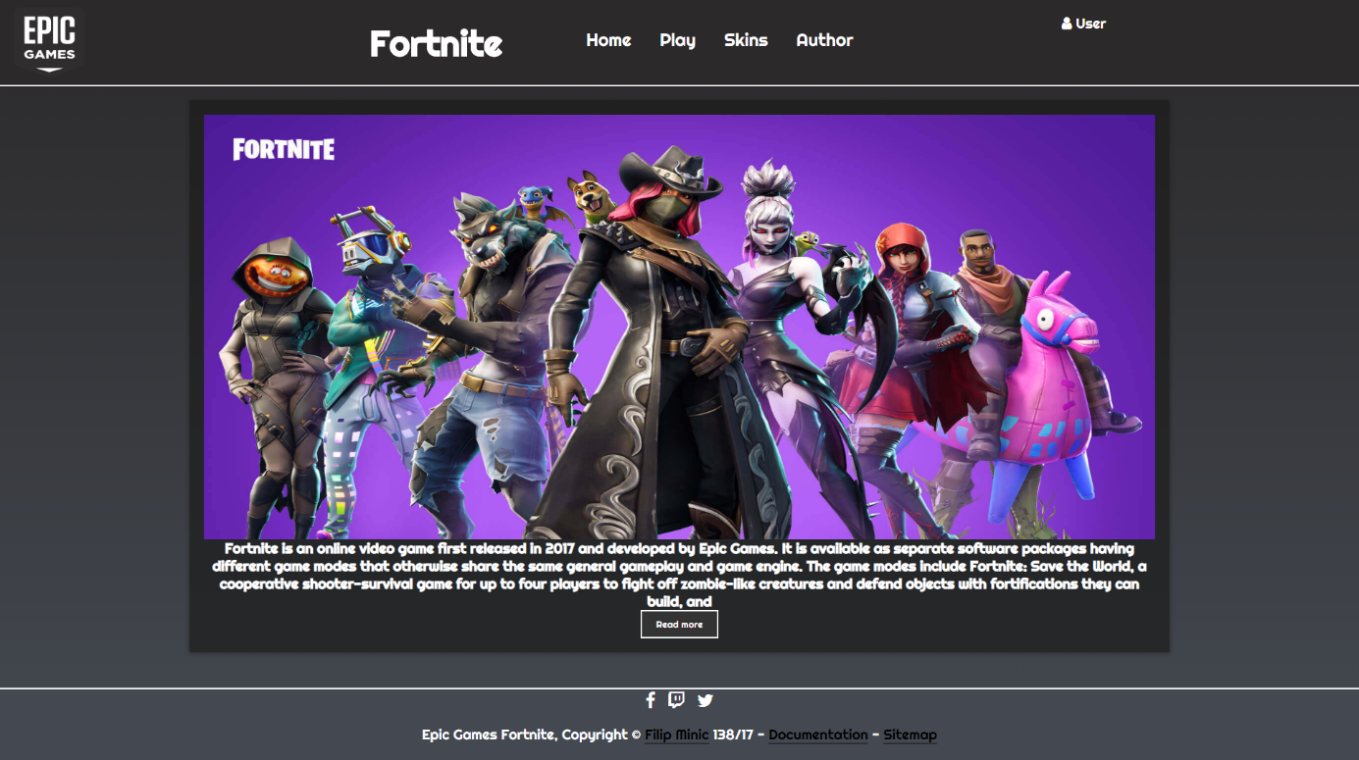

Na index.html strani je ucitan plug-in za slajder. Show/Hide dugme

### Play.html

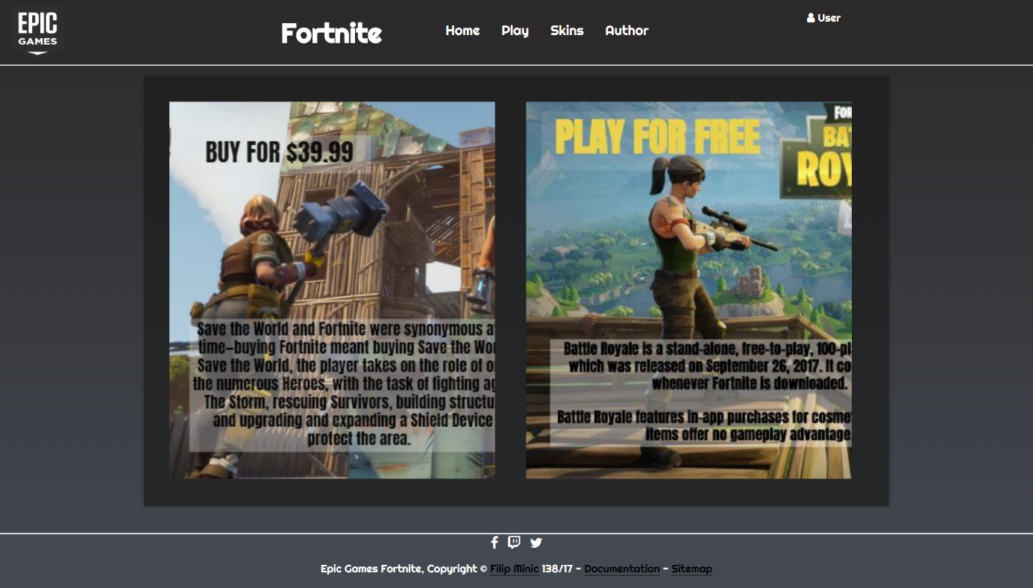

Klikom na levu ili desnu sliku prikazuje sliku u celini, a drugu smanjuje.

Radjeno preko jQuery-ja

### Gallery.html

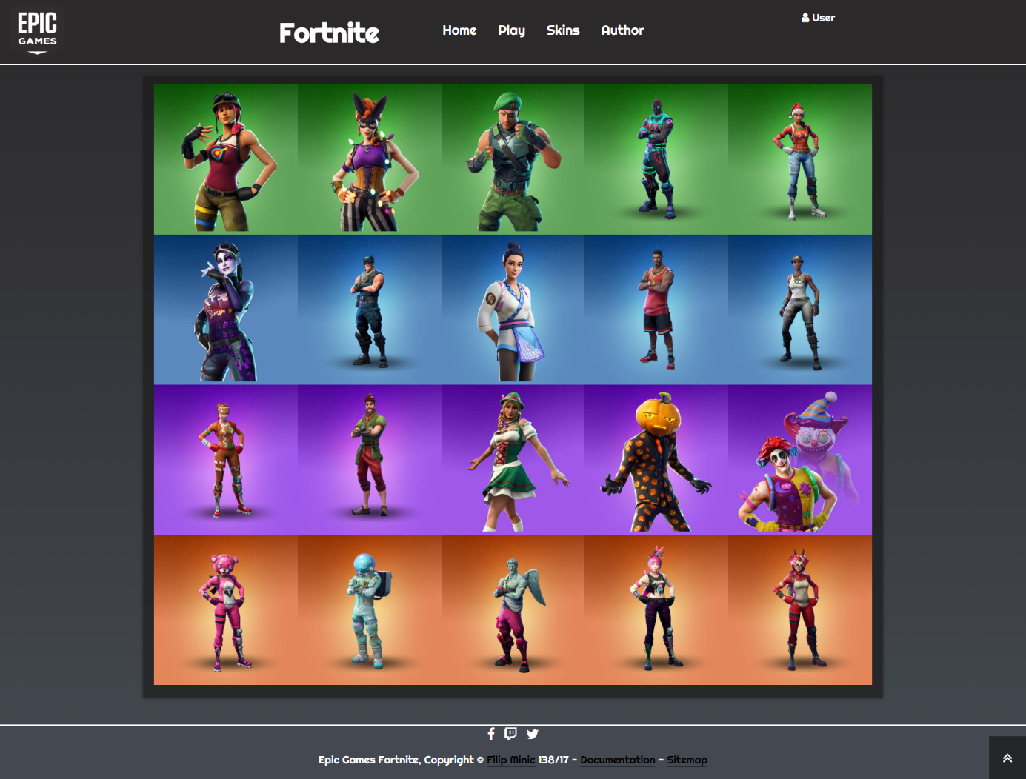

Klikom na sliku pokazuje sliku na sredini ekrana. U donjen desnom uglu stranje se nalazi strelica za vracanje na pocetak stranice u slucaju skrolovanja.

Radjeno preko jQuery-ja.

Dinamicno ucitavanje slika. Radjeno preko JavaScripta.

### Login.html

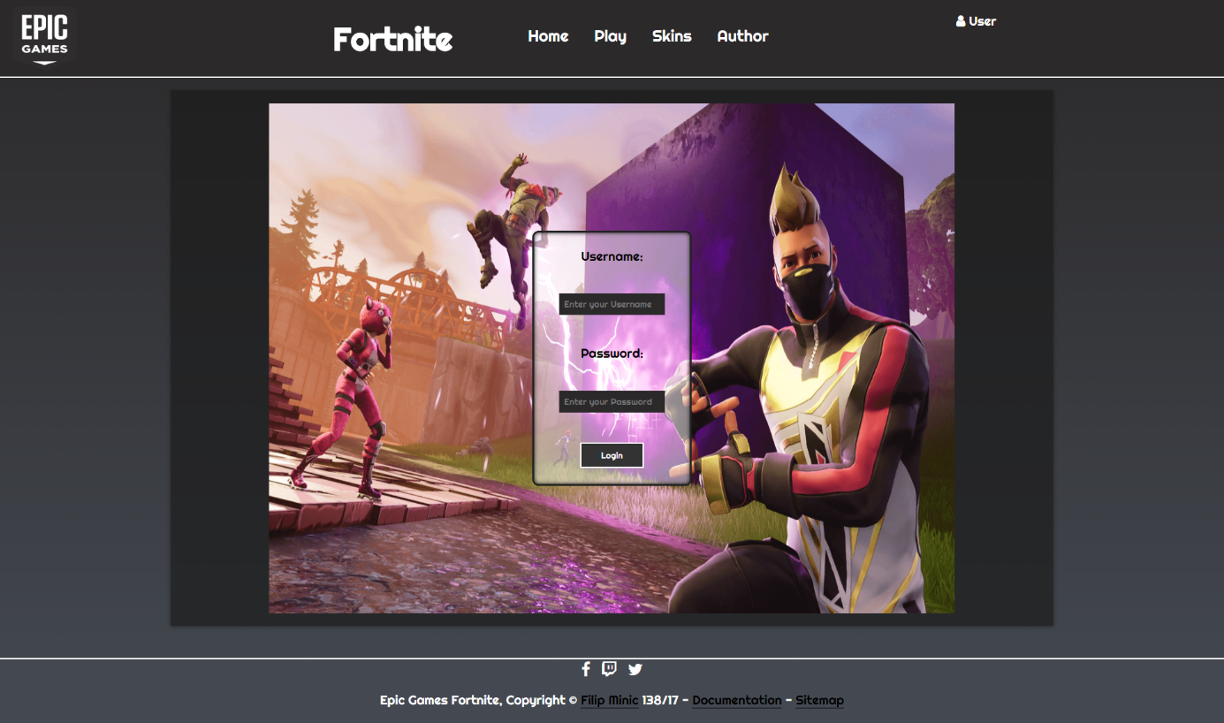

Funkcionalni regularni izrazi . Do provere dolazi klikom na dugme ’Login’.

### Register.html

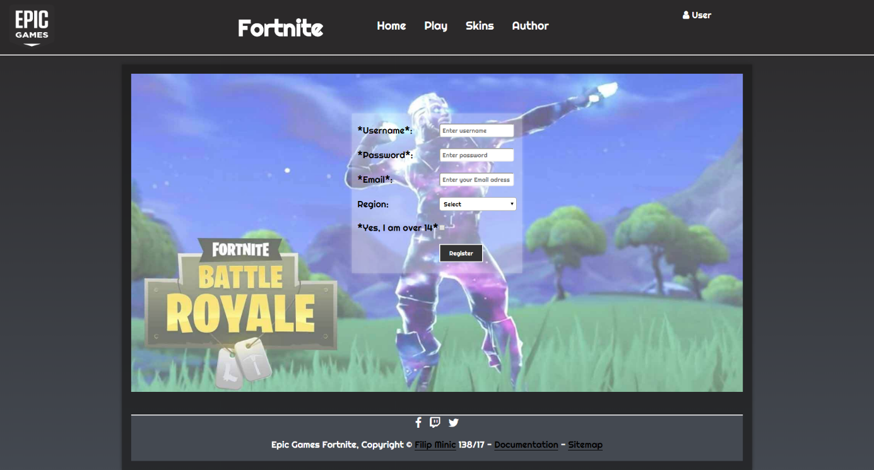

Funkcionalni regularni izrazi . Do provere dolazi klikom na dugme ’Register’.

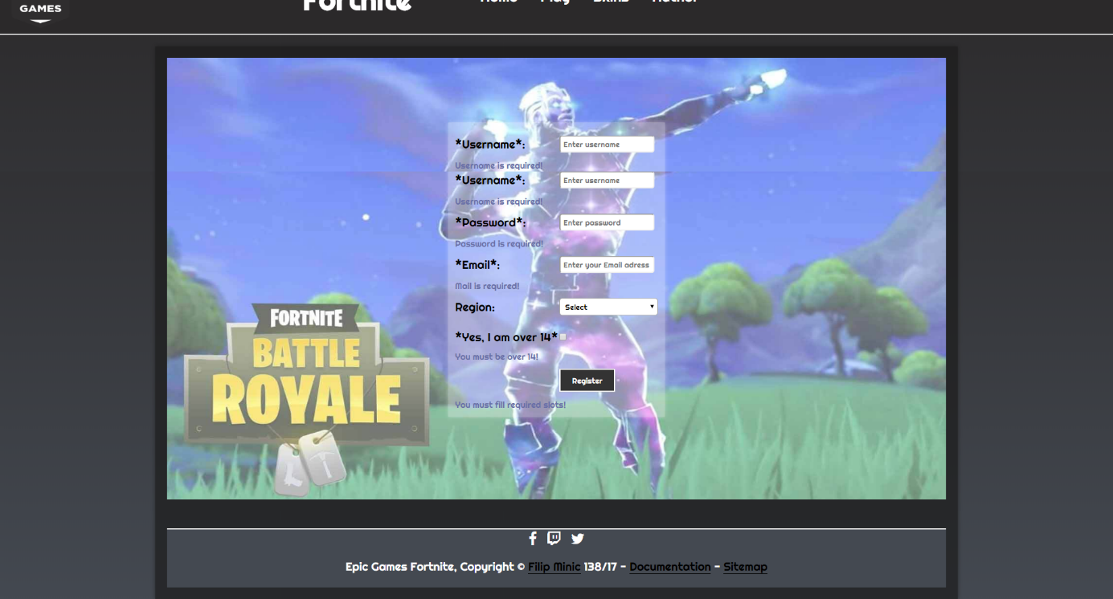

Sve kombinacije su odradjene,samo nisu sve slikane.

### Author.html

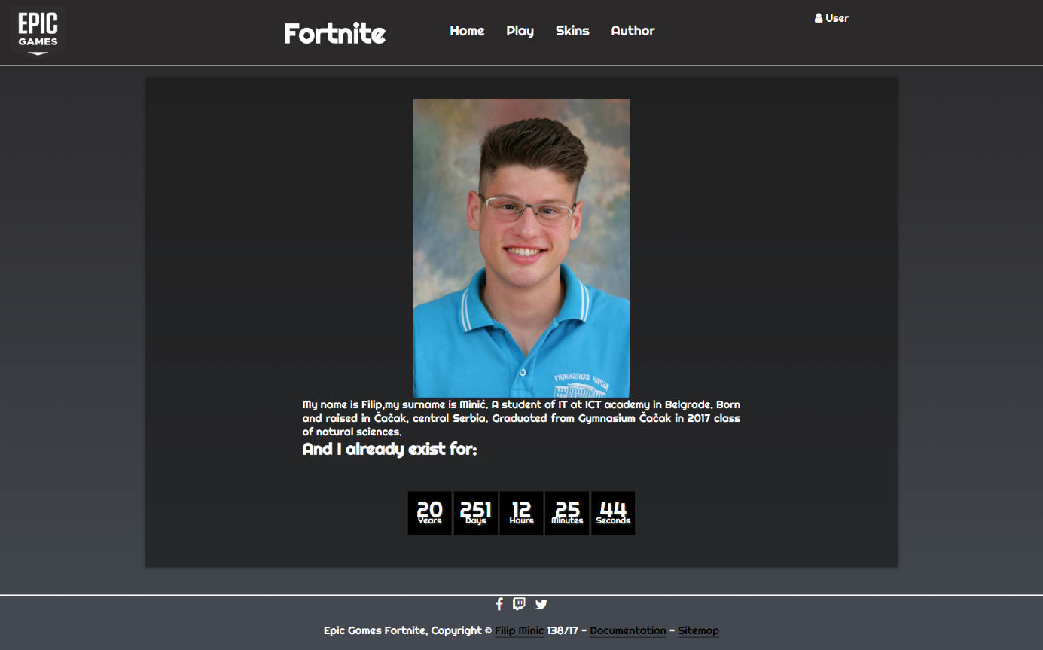

Slajder autorovih slika kao i vreme autorovih godina, koje se menja, uradjeno preko jQuery-ja.

# Kodovi

## 3.1.HTML

### Index.html

<!DOCTYPE html>

<html>

<head>

<title>Epic Games Fortnite | Home</title>

<meta charset="utf-8" />

<meta http-equiv="X-UA-Compatible" content="IE=edge">

<meta name="keywords" content="fortnite, epic, games, save, world, battle, royale"/>

<meta name="description" content="This site is about the Epic Games."/>

<meta name="author" content="Filip Minic" />

<meta name="viewport" content="width=device-width, initial-scale=1">

<link rel="stylesheet" type="text/css" media="screen" href="assets/css/style.css" />

<link rel="stylesheet" href="https://cdnjs.cloudflare.com/ajax/libs/font-awesome/4.7.0/css/font-awesome.min.css">

<link rel="shortcut icon" href="assets/img/malaslicica.jpg" />

</head>

<body>

<div id="strana">

<div class="container">

<header>

<div id="logo">

<a href="index.html"><img src="assets/img/logo.PNG" alt="Logo"></a>

</div>

<div id="header-text">

<h1>Fortnite</h1>

</div>

<nav id="myNav"> </nav>

<div id="account">

<ul id="account1">

<li> <i class="fa fa-user" aria-hidden="true"></i> <a href="#">User</a>

<ul>

<li><a href="login.html">Login</li></a>

<li><a href="register.html">Register</li></a>

</ul>

</li>

</ul>

</div>

<div class="cistac"></div>

</header>

<div id="sadrzaj">

<div id="slajder">

<ul class="rslides">

<li><img src="assets/img/slika0.jpg" alt=""></li>

<li><img src="assets/img/slika1.jpg" alt=""></li>

<li><img src="assets/img/slika2.png" alt=""></li>

</ul>

</div>

<div id="desc">

<h2>

Fortnite is an online video game first released in 2017 and developed by Epic Games.

It is available as separate software packages having different game modes that otherwise share

the same general gameplay and game engine.

The game modes include Fortnite: Save the World, a cooperative shooter-survival game for up to

four players to fight off zombie-like creatures

and defend objects with fortifications they can build, and

</h2>

<h2 id="more">

Fortnite Battle Royale,

a free-to-play battle royale game where up to 100 players fight to be the last person standing.

Both game modes were released in

2017 as early access titles; Save the World is available only for Windows, macOS, PlayStation

4, and Xbox One,

while Battle Royale has been released for those platforms in addition for Nintendo Switch, iOS

and Android devices.

</h2>

<form action="pera.php" method="GET">

<input class="btnStyle" type="submit" value="Read more" id="morebutton" />

</form>

</div>

<div class="cistac"></div>

</div>

<footer>

<div id="snet">

<a href="https://www.facebook.com/FortniteGame/"><i class="fa fa-facebook" aria-hidden="true"></i></a>

<a href="https://www.twitch.tv/directory/game/Fortnite"><i class="fa fa-twitch" aria-hidden="true"></i></a>

<a href="https://twitter.com/FortniteGame?ref_src=twsrc%5Egoogle%7Ctwcamp%5Eserp%7Ctwgr%5Eauthor"><i

class="fa fa-twitter" aria-hidden="true"></i></a>

</div>

<p>Epic Games Fortnite, Copyright &copy; <a href="author.html">Filip Minic</a> 138/17 - <a href="#">Documentation</a> - <a href="sitemap.xml">Sitemap</a></p>

</footer>

</div>

</div>

<script src="https://ajax.googleapis.com/ajax/libs/jquery/3.2.1/jquery.min.js"></script>

<script src="assets/js/main.js" type="text/javascript"></script>

<script src="assets/js/jQuery.js" type="text/javascript"></script>

<script src="assets/js/responsiveslides.min.js"></script>

</body>

</html>

### Play.html

<!DOCTYPE html>

<html>

<head>

<title>Epic Games Fortnite | Play</title>

<meta charset="utf-8" />

<meta http-equiv="X-UA-Compatible" content="IE=edge">

<meta name="keywords" content="fortnite, epic, games, save, world, battle, royale, game, modes"/>

<meta name="description" content="This page is about game modes in the game."/>

<meta name="author" content="Filip Minic" />

<meta name="viewport" content="width=device-width, initial-scale=1">

<link rel="stylesheet" type="text/css" media="screen" href="assets/css/style.css" />

<link rel="stylesheet" href="https://cdnjs.cloudflare.com/ajax/libs/font-awesome/4.7.0/css/font-awesome.min.css">

<link rel="shortcut icon" href="assets/img/malaslicica.jpg" />

</head>

<body>

<div id="strana">

<div class="container">

<header>

<div id="logo">

<a href="index.html"><img src="assets/img/logo.PNG" alt="Logo"></a>

</div>

<div id="header-text">

<h1>Fortnite</h1>

</div>

<nav id="myNav"> </nav>

<div id="account">

<ul id="account1">

<li> <i class="fa fa-user" aria-hidden="true"></i> <a href="#">User</a>

<ul>

<li><a href="login.html">Login</li></a>

<li><a href="register.html">Register</li></a>

</ul>

</li>

</ul>

</div>

<div class="cistac"></div>

</header>

<div id="sadrzaj">

<div id="gameMode">

<div id="stw" class="gameBox gb_left">

<div class="innerBox">

</div>

</div>

<div id="br" class="gameBox gb_right">

<div class="innerBox">

</div>

</div>

</div>

</div>

<footer>

<div id="snet">

<a href="https://www.facebook.com/FortniteGame/"><i class="fa fa-facebook" aria-hidden="true"></i></a>

<a href="https://www.twitch.tv/directory/game/Fortnite"><i class="fa fa-twitch" aria-hidden="true"></i></a>

<a href="https://twitter.com/FortniteGame?ref_src=twsrc%5Egoogle%7Ctwcamp%5Eserp%7Ctwgr%5Eauthor"><i

class="fa fa-twitter" aria-hidden="true"></i></a>

</div>

<p>Epic Games Fortnite, Copyright &copy; <a href="author.html">Filip Minic</a> 138/17 - <a href="#">Documentation</a> - <a href="sitemap.xml">Sitemap</a></p>

</footer>

</div>

</div>

<script src="https://ajax.googleapis.com/ajax/libs/jquery/3.2.1/jquery.min.js"></script>

<script src="assets/js/main.js" type="text/javascript"></script>

<script src="assets/js/jQuery.js" type="text/javascript"></script>

<script src="assets/js/responsiveslides.min.js"></script>

</body>

</html>

### Gallery.html

<!DOCTYPE html>

<html>

<head>

<title>Epic Games Fortnite | Skins</title>

<meta charset="utf-8" />

<meta http-equiv="X-UA-Compatible" content="IE=edge">

<meta name="keywords" content="fortnite, epic, games, save, world, battle, royale, skins, best, game, ever"/>

<meta name="description" content="This page is about pictures and skins in the game."/>

<meta name="author" content="Filip Minic" />

<meta name="viewport" content="width=device-width, initial-scale=1">

<link rel="stylesheet" type="text/css" media="screen" href="assets/css/style.css" />

<link rel="stylesheet" href="https://cdnjs.cloudflare.com/ajax/libs/font-awesome/4.7.0/css/font-awesome.min.css">

<link rel="shortcut icon" href="assets/img/malaslicica.jpg" />

</head>

<body>

<div id="strana">

<div class="container">

<header>

<div id="logo">

<a href="index.html"><img src="assets/img/logo.PNG" alt="Logo"></a>

</div>

<div id="header-text">

<h1>Fortnite</h1>

</div>

<nav id="myNav"> </nav>

<div id="account">

<ul id="account1">

<li> <i class="fa fa-user" aria-hidden="true"></i> <a href="#">User</a>

<ul>

<li><a href="login.html">Login</li></a>

<li><a href="register.html">Register</li></a>

</ul>

</li>

</ul>

</div>

<div class="cistac"></div>

</header>

<div id="sadrzaj">

<div id="gallerija"></div>

<div id="preview"></div>

<div id="overlay"></div>

</div>

<div id="futer">

<footer>

<div id="snet">

<a href="https://www.facebook.com/FortniteGame/"><i class="fa fa-facebook" aria-hidden="true"></i></a>

<a href="https://www.twitch.tv/directory/game/Fortnite"><i class="fa fa-twitch" aria-hidden="true"></i></a>

<a href="https://twitter.com/FortniteGame?ref_src=twsrc%5Egoogle%7Ctwcamp%5Eserp%7Ctwgr%5Eauthor"><i

class="fa fa-twitter" aria-hidden="true"></i></a>

</div>

<p>Epic Games Fortnite, Copyright &copy; <a href="author.html">Filip Minic</a> 138/17 - <a href="#">Documentation</a> - <a href="sitemap.xml">Sitemap</a></p>

</footer>

</div>

</div>

<div id="scrollTop"><i class="fa fa-angle-double-up"></i></div>

</div>

<script src="https://ajax.googleapis.com/ajax/libs/jquery/3.2.1/jquery.min.js"></script>

<script src="assets/js/main.js" type="text/javascript"></script>

<script src="assets/js/jQuery.js" type="text/javascript"></script>

<script src="assets/js/responsiveslides.min.js"></script>

<script src="assets/js/gallery.js" type="text/javascript"></script>

</body>

</html>

### Login.html

<!DOCTYPE html>

<html>

<head>

<title>Epic Games Fortnite | Login</title>

<meta charset="utf-8" />

<meta http-equiv="X-UA-Compatible" content="IE=edge">

<meta name="keywords" content="fortnite, epic, games, save, world, battle, royale, login"/>

<meta name="description" content="Page for loggin."/>

<meta name="author" content="Filip Minic" />

<meta name="viewport" content="width=device-width, initial-scale=1">

<link rel="stylesheet" type="text/css" media="screen" href="assets/css/style.css" />

<link rel="stylesheet" href="https://cdnjs.cloudflare.com/ajax/libs/font-awesome/4.7.0/css/font-awesome.min.css">

<link rel="shortcut icon" href="assets/img/malaslicica.jpg" />

</head>

<body>

<div id="strana">

<div class="container">

<header>

<div id="logo">

<a href="index.html"><img src="assets/img/logo.PNG" alt="Logo"></a>

</div>

<div id="header-text">

<h1>Fortnite</h1>

</div>

<nav id="myNav"> </nav>

<div id="account">

<ul id="account1">

<li> <i class="fa fa-user" aria-hidden="true"></i> <a href="#">User</a>

<ul>

<li><a href="login.html">Login</li></a>

<li><a href="register.html">Register</li></a>

</ul>

</li>

</ul>

</div>

<div class="cistac"></div>

</header>

<div id="sadrzaj">

<div id="loginForma">

<table>

<form action="#" method="GET">

<tr>

<td id="errorUser">

<p>Username: </p>

</td>

</tr>

<tr>

<td>

<input type="text" id="loginUser" placeholder="Enter your Username">

</td>

</tr>

<tr>

<td id="errorPassword">

<p>Password:</p>

</td>

</tr>

<tr>

<td>

<input type="password" id="loginPass" placeholder="Enter your Password">

</td>

</tr>

<tr>

<td>

<input class="btnStyle" type="button" id="loginButton" value="Login">

</td>

</tr>

</form>

</table>

</div>

<div class="cistac"></div>

</div>

<footer>

<div id="snet">

<a href="https://www.facebook.com/FortniteGame/"><i class="fa fa-facebook" aria-hidden="true"></i></a>

<a href="https://www.twitch.tv/directory/game/Fortnite"><i class="fa fa-twitch" aria-hidden="true"></i></a>

<a href="https://twitter.com/FortniteGame?ref_src=twsrc%5Egoogle%7Ctwcamp%5Eserp%7Ctwgr%5Eauthor"><i

class="fa fa-twitter" aria-hidden="true"></i></a>

</div>

<p>Epic Games Fortnite, Copyright &copy; <a href="author.html">Filip Minic</a> 138/17 - <a href="#">Documentation</a> - <a href="sitemap.xml">Sitemap</a></p>

</footer>

</div>

</div>

<script src="https://ajax.googleapis.com/ajax/libs/jquery/3.2.1/jquery.min.js"></script>

<script src="assets/js/main.js" type="text/javascript"></script>

<script src="assets/js/jQuery.js" type="text/javascript"></script>

<script src="assets/js/login.js" type="text/javascript"></script>

</body>

</html>

### Register.html

<!DOCTYPE html>

<html>

<head>

<title>Epic Games Fortnite | Register</title>

<meta charset="utf-8" />

<meta http-equiv="X-UA-Compatible" content="IE=edge">

<meta name="keywords" content="fortnite, epic, games, save, world, battle, royale, register"/>

<meta name="description" content="Page for register."/>

<meta name="author" content="Filip Minic" />

<meta name="viewport" content="width=device-width, initial-scale=1">

<link rel="stylesheet" type="text/css" media="screen" href="assets/css/style.css" />

<link rel="stylesheet" href="https://cdnjs.cloudflare.com/ajax/libs/font-awesome/4.7.0/css/font-awesome.min.css">

<link rel="shortcut icon" href="assets/img/malaslicica.jpg" />

</head>

<body>

<div id="strana">

<div class="container">

<header>

<div id="logo">

<a href="index.html"><img src="assets/img/logo.PNG" alt="Logo"></a>

</div>

<div id="header-text">

<h1>Fortnite</h1>

</div>

<nav id="myNav"> </nav>

<div id="account">

<ul id="account1">

<li> <i class="fa fa-user" aria-hidden="true"></i> <a href="#">User</a>

<ul>

<li><a href="login.html">Login</li></a>

<li><a href="register.html">Register</li></a>

</ul>

</li>

</ul>

</div>

<div class="cistac"></div>

</header>

<div id="sadrzaj">

<div id="registerback">

<div id="divTabela">

<table>

<form action="peera.php" method="GET">

<tr>

<td>*Username*:</td>

<td><input type="text" name="name" id="tbusername" placeholder="Enter username"></td>

</tr>

<tr>

<td colspan="2">

<p id="errorname"></p>

</td>

</tr>

<tr>

<td>*Password*:</td>

<td><input type="password" name="pass" id="tbpassword" placeholder="Enter password"></td>

</tr>

<tr>

<td colspan="2">

<p id="errorpass"></p>

</td>

</tr>

<tr>

<td>*Email*:</td>

<td><input type="text" name="mail" id="tbmail" placeholder="Enter your Email adress"></td>

</tr>

<tr>

<td colspan="2">

<p id="errormail"></p>

</td>

</tr>

<tr>

<td>Region:</td>

<td id="ddlreg"></td>

</tr>

<tr>

<td colspan="2">

<p id="errorreg"></p>

</td>

</tr>

<tr>

<td>*Yes, I am over 14*</td>

<td><input type="checkbox" name="chb14" id="chb" /></td>

</tr>

<tr>

<td colspan="2">

<p id="errorold"></p>

</td>

</tr>

<tr>

<td></td>

<td><input class="btnStyle" type="button" value="Register" id="btnReg" /></td>

</tr>

<tr>

<td colspan="2">

<p id="errorregister"></p>

</td>

</tr>

</form>

</table>

</div>

</div>

<div class="cistac"></div>

<footer>

<div id="snet">

<a href="https://www.facebook.com/FortniteGame/"><i class="fa fa-facebook" aria-hidden="true"></i></a>

<a href="https://www.twitch.tv/directory/game/Fortnite"><i class="fa fa-twitch" aria-hidden="true"></i></a>

<a href="https://twitter.com/FortniteGame?ref_src=twsrc%5Egoogle%7Ctwcamp%5Eserp%7Ctwgr%5Eauthor"><i

class="fa fa-twitter" aria-hidden="true"></i></a>

</div>

<p>Epic Games Fortnite, Copyright &copy; <a href="author.html">Filip Minic</a> 138/17 - <a href="#">Documentation</a> - <a href="sitemap.xml">Sitemap</a></p>

</footer>

</div>

</div>

</div>

<script src="https://ajax.googleapis.com/ajax/libs/jquery/3.2.1/jquery.min.js"></script>

<script src="assets/js/main.js" type="text/javascript"></script>

<script src="assets/js/jQuery.js" type="text/javascript"></script>

<script src="assets/js/register.js" type="text/javascript"></script>

</body>

</html>

### Author.html

<!DOCTYPE html>

<html>

<head>

<title>Epic Games Fortnite | Author</title>

<meta charset="utf-8" />

<meta http-equiv="X-UA-Compatible" content="IE=edge">

<meta name="keywords" content="author, creator, gamer, programmer"/>

<meta name="description" content="This site is about author of this site."/>

<meta name="author" content="Filip Minic" />

<meta name="viewport" content="width=device-width, initial-scale=1">

<link rel="stylesheet" type="text/css" media="screen" href="assets/css/style.css" />

<link rel="stylesheet" href="https://cdnjs.cloudflare.com/ajax/libs/font-awesome/4.7.0/css/font-awesome.min.css">

<link rel="shortcut icon" href="assets/img/malaslicica.jpg" />

</head>

<body>

<div id="strana">

<div class="container">

<header>

<div id="logo">

<a href="index.html"><img src="assets/img/logo.PNG" alt="Logo"></a>

</div>

<div id="header-text">

<h1>Fortnite</h1>

</div>

<nav id="myNav"> </nav>

<div id="account">

<ul id="account1">

<li> <i class="fa fa-user" aria-hidden="true"></i> <a href="#">User</a>

<ul>

<li><a href="login.html">Login</li></a>

<li><a href="register.html">Register</li></a>

</ul>

</li>

</ul>

</div>

<div class="cistac"></div>

</header>

<div id="sadrzaj">

<div id="author">

<div id="slider">

<ul id="images"></ul>

</div>

</div>

<div id="autortext">

<p>

My name is Filip,my surname is Minić.

A student of IT at ICT academy in Belgrade.

Born and raised in Čačak, central Serbia. Graduated from

Gymnasium Čačak in 2017 class of natural sciences.

<h2>And I already exist for:</h2>

</p>

</div>

<div id="countdown">

<div class="ct_block">

<div class="ct_god ct_value"></div>

<div class="ct_unit">Years</div>

</div>

<div class="ct_block">

<div class="ct_dani ct_value"></div>

<div class="ct_unit">Days</div>

</div>

<div class="ct_block">

<div class="ct_sati ct_value"></div>

<div class="ct_unit">Hours</div>

</div>

<div class="ct_block">

<div class="ct_minutes ct_value"></div>

<div class="ct_unit">Minutes</div>

</div>

<div class="ct_block">

<div class="ct_seconds ct_value"></div>

<div class="ct_unit">Seconds</div>

</div>

</div>

<div class="cistac"></div>

</div>

<footer>

<div id="snet">

<a href="https://www.facebook.com/FortniteGame/"><i class="fa fa-facebook" aria-hidden="true"></i></a>

<a href="https://www.twitch.tv/directory/game/Fortnite"><i class="fa fa-twitch" aria-hidden="true"></i></a>

<a href="https://twitter.com/FortniteGame?ref_src=twsrc%5Egoogle%7Ctwcamp%5Eserp%7Ctwgr%5Eauthor"><i

class="fa fa-twitter" aria-hidden="true"></i></a>

</div>

<p>Epic Games Fortnite, Copyright &copy; <a href="author.html">Filip Minic</a> 138/17 - <a href="#">Documentation</a> - <a href="sitemap.xml">Sitemap</a> </p>

</footer>

</div>

</div>

<script src="https://ajax.googleapis.com/ajax/libs/jquery/3.2.1/jquery.min.js"></script>

<script src="assets/js/main.js" type="text/javascript"></script>

<script src="assets/js/jQuery.js" type="text/javascript"></script>

<script src="assets/js/author.js" type="text/javascript"></script>

</body>

</html>

## 3.2. CSS

### Style

@import url('https://fonts.googleapis.com/css?family=Josefin+Sans|Righteous');

*{

    margin:0px;

    padding:0px;

    font-family: 'Righteous', sans-serif;

}

.cistac{

    clear: both;

}

ul{

    list-style-type: none;

}

a{

    text-decoration: none;

}

#strana{

    background-color:#444951;

    font:Arial, Helvetica,sans-serif;

    padding:0;

    margin:0 auto;

    width: 100%;

}

.container{

    margin:0px auto;

    background: linear-gradient(to bottom, #2b292a 0%,#444951 100%);

}

/*******************Header*******************/

header{

    width: 100%;

    height: 120px;

    border-bottom:2px solid #fff;

    background: #2b292a;

}

#logo{

    width: 20%;

    height: 100px;

    float:left;

    padding: 10px 20px 10px 20px;

}

#logo img{

    width: 100px;

    height: 100px;

}

#header-text{

    width: 20%;

    height: 120px;

    float: left;

}

#header-text h1{

    text-align: center;

    font-size: 50px;

    color: #fff;

    padding: 30px 0px 30px 0px;

}

nav{

    width: 35%;

    height: 120px;

    float: left;

}

nav li{

    float:left;

    display:inline;

    padding: 40px 20px;

    font-size: 25px;

}

nav li a{

    color: #fff;

}

nav ul li a:hover{

    border-bottom: 3px solid #fff;

}

#account{

    width: 5%;

    height: 50px;

    float: left;

    font-size: 30px;

    color: #fff;

    padding: 20px;

}

#account ul li a {

    font-size: 20px;

    color: #fff;

}

#account1 {

    font-size: 20px;

}

/*************************Sadrzaj*****************/

#sadrzaj{

    width: 70%;

    margin: 20px auto 0px auto;

    padding: 20px;

    min-height: 100%;

    background: rgba(27,27,27,0.7);

    box-shadow: 0px 0px 10px rgba(27,27,27,0.7);

}

/*******************sadrzajIndex********************/

#slajder ul li img{

    width: 100%;

    height: 600px;

}

#desc{

    width: 100%;

    text-align: center;

}

#desc h2{

    color: #fff;

    font-size: 20px;

}

/**************SadrzajRegister****************/

#divTabela{

    width: 100%;

    height: 700px;

    margin: 0px auto;

    color: #fff;

}

#divTabela table {

    margin: 0px auto;

    text-align: left;

    font-size: 20px;

    color: #000;

    position: relative;

    transform: translate(0%, 25%);

    background: rgba(255,255,255, 0.3);

    padding: 10px;

    box-shadow: 0px 0px 10px rgba(255,255,255, 0.3);

}

#divTabela table tr td{

    padding-top: 10px;

}

#ddlregister{

    width: 170px;

    border-radius: 5px;

    padding: 5px;

}

#registerback{

    width: 100%;

    height: 700px;

    background: url('../img/1.jpg') no-repeat 0;

    background-size: 100% 100%;

}

#tbusername, #tbpassword, #tbmail{

    border-radius: 5px;

    padding: 5px;

}

#errorname,#errorpass, #errormail, #errorreg, #errorold,#errorregister, #errorreg{

    color: #696fa8;

    font-size: 15px;

}

.text-success{

    color:#000;

}

.text-success a{

    color:#000;

    border-bottom: 1px solid #000;

}

/**************Sarzaj Login***********/

#loginForma{

    width: 80%;

    height: 600px;

    margin: 0px auto;

    padding-top: 200px;

    background: url('../img/2.png') no-repeat 0;

    background-size: 100% 100%;

}

#loginForma table{

    margin: 0px auto;

width: 250px;

height: 400px;

border: 3px solid #222;

box-shadow: inset 0px 0px 10px #222;

    border-radius: 10px;

    background: rgba(255,255,255,.5);

    text-align: center;

font-size: 20px;

position: relative;

}

#loginForma table tr td{

    padding: 5px;

}

#loginButton{

    padding: 10px;

    width: 100px;

}

#loginUser,

#loginPass{

border: none;

padding: 5px;

background: #2b292a;

color: #fff;

transition: 200ms ease-in-out;

padding: 8px 8px;

font-size: 14px;

}

#loginUser:hover,

#loginPass:hover{

background: #3a3739;

}

#loginUser:focus,

#loginPass:focus{

background: #1b1a1b;

}

/***************Footer****************/

footer{

    border-top: 2px solid white;

    width: 100%;

    height: 100px;

    margin-top: 50px;

background: #444951;

}

footer p {

    text-align: center;

    font-size:20px;

    color: #fff;

    margin-top: 20px;

}

footer p a{

    color: #000;

    border-bottom: 1px solid #000;

    transition: 200ms ease-in-out;

}

footer p a:hover{

    color: #2b292a

}

#snet{

    background-color: #444951;

    text-align: center;

    font-size: 25px;

}

#snet a{

    padding: 5px;

    color: #fff;

}

/*************Buttons**********/

.btnStyle{

    border: 2px solid #fff;

    background: #333;

    color: #fff;

}

.btnStyle:hover{

    border: 2px solid #333;

    background: #fff;

    color: #333;

    cursor: pointer;

    transition: 300ms ease-in-out;

}

#btnReg.btnStyle,#morebutton.btnStyle{

    padding: 10px 20px;

}

/****Plugin***********/

.rslides {

    position: relative;

    list-style: none;

    overflow: hidden;

    width: 100%;

    padding: 0;

    margin: 0;

}

.rslides li {

    -webkit-backface-visibility: hidden;

    position: absolute;

    display: none;

    width: 100%;

    left: 0;

    top: 0;

}

.rslides li:first-child {

    position: relative;

    display: block;

    float: left;

}

.rslides img {

    display: block;

    height: auto;

    float: left;

    width: 100%;

    border: 0;

}

/******** Gallery Skins ***********/

.gImg{

    width: 20%;

    transition: 300ms ease-in-out;

    margin-top: -4px;

}

.imgBox{

    display: inline;

}

#preview{

    display: none;

    position: fixed;

    left: 50%;

    top: 50%;

    transform: translate(-50%, -50%);

    height: 60%;

    width: auto;

    z-index: 2;

}

#preview img {

    height: 100%;

    width: auto;

}

#closePreview{

    position: absolute;

    top: 0px;

    right: 0px;

    height: 25px;

    width: 25px;

    color: red;

    background: #ccc;

    text-align: center;

    line-height: 25px;

    cursor: pointer;

}

#closePreview:hover{

    background: #464646;

}

#overlay{

    position: fixed;

    left: 0px;

    top: 0px;

    background: rgba(0,0,0,0.8);

    width: 100%;

    height: 100%;

    display: none;

    z-index: 1;

}

/*Skrol na pocetak*/

#scrollTop

{

    background:#252628;;

    position:fixed;

    bottom:0px;

    right:0px;

    padding:25px;

    display:none;

}

#scrollTop i{

    color: #fff;

    font-size: 30px;

}

/************** Play ***************/

#gamemode{

    width: 100%;

    height: 800px;

}

.gameBox{

    width: 45%;

    display: inline-block;

    min-height: 700px;

    margin: 2%;

    transition: 300ms ease-in-out;

    cursor: pointer;

}

.gb_left{

    background-image: url("../img/gamemode1.jpg");

    background-repeat: no-repeat;

    background-size: auto 100%;

}

.gb_right{

    background-image: url("../img/battleroyale.jpg");

    background-repeat: no-repeat;

    background-size: auto 100%;

}

/******fa fa hover********/

.fa-twitter{

    transition: 200ms ease-in-out;

}

.fa-twitter:hover{

    color: #1da1f2;

}

.fa-twitch{

    transition: 200ms ease-in-out;

}

.fa-twitch:hover{

    color: #613f9f;

}

.fa-facebook{

    transition: 200ms ease-in-out;

}

.fa-facebook:hover{

    color: #395694;

}

/********Author********/

#slider {

    position: relative;

    overflow: hidden;

    margin: 20px auto 0 auto;

}

#slider ul {

    position: relative;

    margin: 0;

    padding: 0;

    height: 200px;

    list-style: none;

}

#slider ul li {

    position: relative;

    display: block;

    float: left;

    margin: 0;

    padding: 0;

    width: 400px;

    height: 550px;

    background: #ccc;

    text-align: center;

    line-height: 300px;

}

.slider_image{

    width: 100%;

    height: auto;

}

#autortext{

    width: 60%;

    margin: 0 auto;

    text-align: justify;

    font-size: 20px;

    color: #fff;

}

/*Countdown*/

#countdown{

    position: relative;

    left: 50%;

    top: 50%;

    transform: translate(-50%, -50%);

    text-align: center;

    color: #333;

    user-select: none;

    margin-top: 100px;

}

.ct_block{

    display: inline-block;

    height: 80px;

    width: 80px;

    background: #000;

    box-shadow: inset 0px 0px 10px #000;

}

.ct_value{

    font-size: 40px;

    color:#fff;

    position: relative;

    top: 40%;

    transform: translate(0%, -50%);

    text-shadow: 2px 2px 3px rgba(255,255,255,0.25);

}

.ct_unit{

    transform: translate(0%, -50%);

    color:#fff;

    position: relative;

    top: 5%;

    left: 0px;

    font-size:16px;

    text-shadow: 2px 2px 3px rgba(255,255,255,0.25);

}

.ct_row{

    margin-bottom: 3px;

}

## 3.3. JavaScript

### Main.js

//Ucitan Nav meni koji se nalazi na svakoj strani sajta

window.onload = function(){

var ispis = "<ul>";

var nizlista = ["<li><a href='index.html'>Home</a></li>",

"<li><a href='play.html'>Play</a></li>",

"<li><a href='gallery.html'>Skins</a></li>",

"<li><a href='author.html'>Author</a></li>",

];

for(var j=0; j<nizlista.length; j++){

ispis+=nizlista[j];};

ispis+="</ul>";

document.getElementById("myNav").innerHTML = ispis;

}

### Gallery.js

// Array sa slikama i alt

imgs = ["g6.jpg","g7.jpg", "g8.jpg", "g9.jpg", "g10.jpg", "g11.jpg", "g12.jpg", "g13.jpg", "g14.jpg", "g15.jpg", "g16.jpg", "g17.jpg", "g18.jpg", "g19.jpg", "g20.jpg", "g21.jpg", "g22.jpg", "g23.jpg", "g24.jpg", "g25.jpg"];

alt = ["Skin6","Skin7", "Skin8", "Skin9", "Skin10", "Skin11", "Skin12", "Skin13", "Skin14", "Skin15","Skin16", "Skin17", "Skin18", "Skin19", "Skin20","Skin21", "Skin22", "Skin23", "Skin24", "Skin25"];

// Selector za galleriju

galleryContainer = document.getElementById("gallerija");

// Loop da napuni galleriju

for(i=0; i < imgs.length; i++){

galleryContainer.innerHTML += "<div class='imgBox'><img class='gImg' alt='"+alt[i]+"' src='./assets/img/"+imgs[i]+"'/></div>";

}

$(document).ready(function(){

//klik na slike gallery.html

$(".gImg").on("mouseenter", function(){

$(this).css({

"cursor":"pointer",

"filter": "brightness(80%)"

})

}).on("mouseleave", function(){

$(this).css({

"cursor":"default",

"filter": "brightness(100%)"

})

});

// Regulisanje od preview slike

$(".gImg").on("click", function(){

mySrc = $(this).attr("src");

$("#preview").html("<img class='' src='"+mySrc+"'/><div id='closePreview'>X</div>");

$("#preview").fadeIn(500);

$("#overlay").fadeIn(500);

});

$(document).on("click", "#closePreview", function(){

$("#preview").fadeOut(500);

$("#overlay").fadeOut(500);

});

});

//Skroll na pocetak strane

window.onscroll = function() {skrolovanje()};

function skrolovanje() {

if (document.documentElement.scrollTop < 17) {

document.getElementById("scrollTop").style.display = "none";

} else {

document.getElementById("scrollTop").style.display = "block";

}

}

$("#scrollTop").click(function(){

document.documentElement.scrollTop = 0;

});

### Login.js

//RE koriscen na login.html

document.getElementById("loginButton").addEventListener("click", proveraLogin);

document.getElementById("loginUser").focus();

function proveraLogin(){

var loginUser = document.getElementById("loginUser");

var loginPass = document.getElementById("loginPass");

var reloginUser = /^[A-z]+$/;

var reloginPass = /^(?=.*[A-Za-z])(?=.*\d)[A-Za-z\d]{8,}$/;

var errorUser = document.getElementById("errorUser");

var errorPasswordd = document.getElementById("errorPassword");

if(loginUser == "") {

errorUser.style.color = "red";

} else if(!reloginUser.test(loginUser.value)) {

errorUser.style.color = "red";

} else {

errorUser.style.color = "green";

}

if(loginPass == "") {

errorPasswordd.style.color = "red";

} else if(!reloginPass.test(loginPass.value)) {

errorPasswordd.style.color = "red";

} else {

errorPasswordd.style.color = "green";

}

}

### Register.js

//RE koriscen na register.html

window.addEventListener("load", fillRegion);

document.getElementById("tbusername").focus();

document.getElementById("btnReg").addEventListener("click", provera);

function fillRegion(){

    var region, ispis;

    region = ["Europe ", "NA-East", "NA-West"];

    ispis = "<select id='ddlregister'>";

    ispis +="<option value='0'>Select</option>";

    for(var i = 0; i < region.length; i++){

        ispis += "<option value='" + region[i] + "'>" + region[i] + "</option>";

    }

    ispis += "</select>";

    document.getElementById("ddlreg").innerHTML = ispis;

}

function provera(){

var podaci = [];

var username=document.getElementById("tbusername").value.trim();

var password=document.getElementById("tbpassword").value.trim();

var mail=document.getElementById("tbmail").value.trim();

var tacno="You are over 14";

var usernameError=document.getElementById("errorname");

var passwordError=document.getElementById("errorpass");

var mailError=document.getElementById("errormail");

var reUsername = /^[A-z]+$/;

var rePassword = /^(?=.*[A-Za-z])(?=.*\d)[A-Za-z\d]{8,}$/;

var reeMail = /^[A-z]+\d*\@(gmail|hotmail|yahoo|(ict.edu))\.(com)$/;

if(username == "") {

usernameError.innerHTML = "Username is required!";

} else if(!reUsername.test(username)) {

usernameError.innerHTML = "Use only letters.";

} else {

podaci.push(username);

usernameError.innerHTML = "";

}

if(password == "") {

passwordError.innerHTML = "Password is required!";

} else if(!rePassword.test(password)) {

passwordError.innerHTML = "Use combination of letters and numebrs.(8 or more char)";

} else {

podaci.push(password);

passwordError.innerHTML = "";

}

if(mail == "") {

mailError.innerHTML = "Mail is required!";

} else if(!reeMail.test(mail)) {

mailError.innerHTML = "Use right format for mail.";

} else {

podaci.push(mail);

mailError.innerHTML = "";

}

if(document.getElementById("chb").checked) {

document.getElementById("errorold").innerHTML = "";

podaci.push(tacno);

} else {

document.getElementById("errorold").innerHTML = "You must be over 14!";

}

if(podaci[3]) {

var ispis = "<p class='text-success'>Good job! You are ready to <a href='https://www.epicgames.com/fortnite/en-US/home'>Download</a> game <3 </p>";

document.querySelector("#errorregister").innerHTML = ispis;

} else {

document.querySelector("#errorregister").innerHTML = "You must fill required slots!";

}

}

### Author.js

//Ucitavanje slika i slajder na author.html

img = [

{

src:"autor1.jpg",

alt:"autor1"

},{

src:"autor2.jpg",

alt:"autor2"

},{

src:"autor3.jpg",

alt:"autor3"

},

];

$(document).ready(function($) {

ucitajSlike();

setInterval(function() {

moveRight();

}, 3000);

var slideCount = $("#slider ul li").length;

var slideWidth = $("#slider ul li").width();

var slideHeight = $("#slider ul li").height();

var sliderUlWidth = slideCount * slideWidth;

$("#slider").css({ width: slideWidth, height: slideHeight });

$("#slider ul").css({ width: sliderUlWidth, marginLeft: -slideWidth });

$("#slider ul li:last-child").prependTo("#slider ul");

function moveRight() {

$("#slider ul").animate(

{

left: -slideWidth

},

200,

function() {

$("#slider ul li:first-child").appendTo("#slider ul");

$("#slider ul").css("left", "");

}

);

}

});

function ucitajSlike(){

for(i = 0; i < img.length; i++){

$("#images").append("<li><img class='slider_image' src='./assets/img/"+img[i].src+"' alt='"+img[i].alt+"' /></li>");

}

}

//countdown na author.html

$(document).ready(function(){

countdownInterval = setInterval(function(){

updateCountdown();

}, 1000);

});

function updateCountdown(){

timeNow = Date.now();

rodjendan = new Date("Apr 4, 1998 13:30:14").getTime();

zivim = timeNow - rodjendan;

var years = Math.floor(zivim / (1000 * 60 * 60 * 24) / 365);

var days = Math.floor(zivim / (24 * 60 * 60 * 1000) %365);

var hours = Math.floor((zivim % (1000 * 60 * 60 * 24)) / (1000 * 60 * 60));

var minutes = Math.floor((zivim % (1000 * 60 * 60)) / (1000 * 60));

var seconds = Math.floor((zivim % (1000 * 60)) / 1000);

if(zivim <= 0){

$(".ct_god").text("0");

$(".ct_dani").text("0");

$(".ct_sati").text("0");

$(".ct_minutes").text("0");

$(".ct_seconds").text("0");

clearInterval(countdownInterval);

} else {

$(".ct_god").text(years);

$(".ct_dani").text(days);

$(".ct_sati").text(hours);

$(".ct_minutes").text(minutes);

$(".ct_seconds").text(seconds);

}

}

### jQuery( ostatak )

$(document).ready(function () {

//Hover za login and register

$('#account1 li ul').css({

display: "none",

left: "auto"

});

$('#account1 li').hover(function () {

$(this)

.find('ul')

.stop(true, true)

.slideDown('fast');

}, function () {

$(this)

.find('ul')

.stop(true, true)

.fadeOut('fast');

});

//Plugin Koriscen u index.html za slajder

$(".rslides").responsiveSlides();

// Game Mode logika play.html

openR = false;

openL = false;

$(".gb_right").click(function () { // Click na levi game mode

$(".gb_left>.innerBox").hide();

$(".gb_right>.innerBox").show();

if (openL == false && openR == false) {

$(".gb_right").css({ "background-size": "auto 80%", "width": "80%" });

$(".gb_left").css({ "background-size": "auto 80%", "width": "10%" });

openR = true; openL = false;

} else if (openL == false && openR == true) {

$(".gb_right").css({ "background-size": "auto 100%", "width": "45%" });

$(".gb_left").css({ "background-size": "auto 100%", "width": "45%" });

openR = false; openL = false;

} else if (openL == true && openR == false) {

$(".gb_right").css({ "background-size": "auto 80%", "width": "80%" });

$(".gb_left").css({ "background-size": "auto 80%", "width": "10%" });

openR = true; openL = false;

}

})

$(".gb_left").click(function () { // Click na desni game mode

$(".gb_right>.innerBox").hide();

$(".gb_left>.innerBox").show();

if (openL == false && openR == false) {

$(".gb_right").css({ "background-size": "auto 80%", "width": "10%" });

$(".gb_left").css({ "background-size": "auto 80%", "width": "80%" });

openR = false; openL = true;

} else if (openL == false && openR == true) {

$(".gb_right").css({ "background-size": "auto 80%", "width": "10%" });

$(".gb_left").css({ "background-size": "auto 80%", "width": "80%" });

openR = false; openL = false;

} else if (openL == true && openR == false) {

$(".gb_right").css({ "background-size": "auto 100%", "width": "45%" });

$(".gb_left").css({ "background-size": "auto 100%", "width": "45%" });

openR = false; openL = false;

}

})

//Show and Hide sa index.html

$('#more').hide();

$('#morebutton').click(function (e) {

e.preventDefault();

if ($('#more').is(':visible')) {

$('#more').slideUp();

$(this).val('Read more');

} else {

$('#more').slideDown();

$(this).val('Hide');

}

});

});

### responsiveslides.min.js( plug-in)

/*! http://responsiveslides.com v1.55 by @viljamis */

(function(c,K,C){c.fn.responsiveSlides=function(m){var a=c.extend({auto:!0,speed:500,timeout:4E3,pager:!1,nav:!1,random:!1,pause:!1,pauseControls:!0,prevText:"Previous",nextText:"Next",maxwidth:"",navContainer:"",manualControls:"",namespace:"rslides",before:c.noop,after:c.noop},m);return this.each(function(){C++;var f=c(this),u,t,v,n,q,r,p=0,e=f.children(),D=e.length,h=parseFloat(a.speed),E=parseFloat(a.timeout),w=parseFloat(a.maxwidth),g=a.namespace,d=g+C,F=g+"_nav "+d+"_nav",x=g+"_here",k=d+"_on",

y=d+"_s",l=c("<ul class='"+g+"_tabs "+d+"_tabs' />"),z={"float":"left",position:"relative",opacity:1,zIndex:2},A={"float":"none",position:"absolute",opacity:0,zIndex:1},G=function(){var b=(document.body||document.documentElement).style,a="transition";if("string"===typeof b[a])return!0;u=["Moz","Webkit","Khtml","O","ms"];var a=a.charAt(0).toUpperCase()+a.substr(1),c;for(c=0;c<u.length;c++)if("string"===typeof b[u[c]+a])return!0;return!1}(),B=function(b){a.before(b);G?(e.removeClass(k).css(A).eq(b).addClass(k).css(z),

p=b,setTimeout(function(){a.after(b)},h)):e.stop().fadeOut(h,function(){c(this).removeClass(k).css(A).css("opacity",1)}).eq(b).fadeIn(h,function(){c(this).addClass(k).css(z);a.after(b);p=b})};a.random&&(e.sort(function(){return Math.round(Math.random())-.5}),f.empty().append(e));e.each(function(a){this.id=y+a});f.addClass(g+" "+d);m&&m.maxwidth&&f.css("max-width",w);e.hide().css(A).eq(0).addClass(k).css(z).show();G&&e.show().css({"-webkit-transition":"opacity "+h+"ms ease-in-out","-moz-transition":"opacity "+

h+"ms ease-in-out","-o-transition":"opacity "+h+"ms ease-in-out",transition:"opacity "+h+"ms ease-in-out"});if(1<e.length){if(E<h+100)return;if(a.pager&&!a.manualControls){var H=[];e.each(function(a){a+=1;H+="<li><a href='#' class='"+y+a+"'>"+a+"</a></li>"});l.append(H);m.navContainer?c(a.navContainer).append(l):f.after(l)}a.manualControls&&(l=c(a.manualControls),l.addClass(g+"_tabs "+d+"_tabs"));(a.pager||a.manualControls)&&l.find("li").each(function(a){c(this).addClass(y+(a+1))});if(a.pager||a.manualControls)r=

l.find("a"),t=function(a){r.closest("li").removeClass(x).eq(a).addClass(x)};a.auto&&(v=function(){q=setInterval(function(){e.stop(!0,!0);var b=p+1<D?p+1:0;(a.pager||a.manualControls)&&t(b);B(b)},E)},v());n=function(){a.auto&&(clearInterval(q),v())};a.pause&&f.hover(function(){clearInterval(q)},function(){n()});if(a.pager||a.manualControls)r.bind("click",function(b){b.preventDefault();a.pauseControls||n();b=r.index(this);p===b||c("."+k).queue("fx").length||(t(b),B(b))}).eq(0).closest("li").addClass(x),

a.pauseControls&&r.hover(function(){clearInterval(q)},function(){n()});if(a.nav){g="<a href='#' class='"+F+" prev'>"+a.prevText+"</a><a href='#' class='"+F+" next'>"+a.nextText+"</a>";m.navContainer?c(a.navContainer).append(g):f.after(g);var d=c("."+d+"_nav"),I=d.filter(".prev");d.bind("click",function(b){b.preventDefault();b=c("."+k);if(!b.queue("fx").length){var d=e.index(b);b=d-1;d=d+1<D?p+1:0;B(c(this)[0]===I[0]?b:d);(a.pager||a.manualControls)&&t(c(this)[0]===I[0]?b:d);a.pauseControls||n()}});

a.pauseControls&&d.hover(function(){clearInterval(q)},function(){n()})}}if("undefined"===typeof document.body.style.maxWidth&&m.maxwidth){var J=function(){f.css("width","100%");f.width()>w&&f.css("width",w)};J();c(K).bind("resize",function(){J()})}})}})(jQuery,this,0);